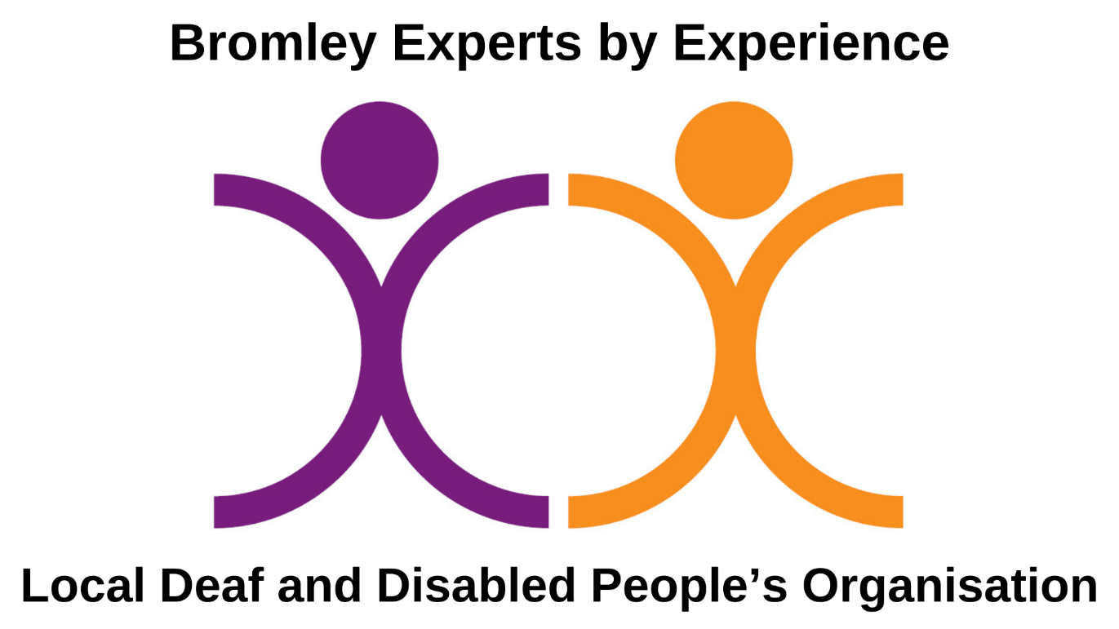
Job Pack
Fundraising and Development Manager
November 2026

Address: Room 5, Anerley Town Hall and Business Centre, Anerley Road, Anerley, SE20 8BD

Telephone calls / messages: 0208 650 2102

Telephone calls / texts: 07552 645 990

Email: hr@xbyxbromley.org.uk

Website: www.xbyxbromley.org.uk Company number: 07976417
Charity number: 1198275

Dear Applicant,

Thank you for enquiring about the post of Fundraising and Development Manager

This pack contains:
- An introduction to Bromley Experts by Experience (X by X Bromley)
- Job description
- Person specification
- Guidance for applicants (it is important you read this)
With additional:
- Application form
- Equality monitoring form

About Bromley Experts by Experience (X by X Bromley)
We are a Deaf and Disabled People’s Organisation (DDPO) in the London Borough of Bromley.
We were established as a Community Interest Company (CIC) by Disabled people in 2012. We became a Charity in 2022.
We are run by and for Deaf and Disabled people and carers in Bromley and neighbouring Boroughs.
All our trustees, staff and volunteers have lived experience.
All our work is informed by lived experience of Disability discrimination, prejudice, oppression and societal barriers to independence and inclusion.
We are part of the Disabled People’s Rights Movement.
Our vision:
We have a vision of a world where Disabled people are able to live their lives independently, in the way they choose, participating fully in society and enjoying equity and respect for diversity.
Our mission:
We aim to enable Deaf and Disabled people and carers in Bromley and neighbouring Boroughs to fully understand our rights, develop collective pride and build skills and experience in self-advocacy and strong civic participation.
We believe this will allow Disabled people to lead in challenging discrimination in Bromley and beyond, breaking down barriers to independence, choice and equity.
Our aims
- Support Disabled people to get our voices heard and to influence change locally.
- Campaign for an inclusive and accessible society.
- Support, develop and celebrate Disabled people’s skills and leadership.
- Improve the sustainability and effectiveness of X by X Bromley so that we strengthen our ability to meet our long-term mission and objectives.
Who we mean by Disabled people:
We believe in the Social Model of Disability. This model was developed over the last 50 years by Disabled people. The Social Model states that people with impairments or differences in their mind or body are ‘disabled’ by the barriers in society which exclude and discriminate. We don’t believe our impairments or differences stop us living the lives we choose, with dignity and independence, it is the barriers in society that prevent this. We work to challenge those barriers.
Our definition of Disabled person therefore includes anyone who is being discriminated against or disabled by societal barriers including:
- People with physical impairment
- People with visual impairment
- Deaf people
- People with hearing impairment
- People who are neurodivergent
- People with learning difficulties
- People who experience mental health conditions / mental distress
- People with long-term health conditions
- Carers of Disabled people (families and friends)
We understand that not all people use the same language to describe themselves. We recognise people’s right to use any language they want to describe themselves.
For example, we support the Deaf Cultural Model. This is another social model way of thinking used by many people within the British Sign Language (BSL) Community. People within the community focus on their shared cultural experiences, histories and sign language and use the term Deaf to describe themselves.
And we recognise the growth of the Neurodiversity Movement. Led originally by autistic people, this movement has come to include people with all sorts of differences in learning, mental processing, sociability, attention or mood. The movement argues that everyone’s brains work differently. Our differences are an advantage in some situations and a disadvantage in others. That is a natural part of human variation. The Neurodiversity Movement challenges the way that society classifies some brain differences as a problem. People in the movement use the term “neurodivergent” to describe those of us whose brain differences sit outside current social standards of “normality.”
What is important to us at X by X is remembering that however we describe ourselves, we are one big community of people experiencing disabling barriers. So at X by X we choose to use the social model term “Disabled people” to describe our whole community.
Who we mean by carers:
When we talk about carers, we mean parents and family or friend carers of Disabled people, not professional carers.
Values and approaches that make us unique:
These are the principles and beliefs we always keep to while we are working towards our aims, and which make us different from other local organisations:
- We always work within the Social Model of Disability and are open to everyone in Bromley and neighbouring Boroughs experiencing disabling barriers.
- We believe in the Disabled People’s Rights Movement approach of “Nothing About Us Without Us”. Disabled people set up, lead and staff our organisation. We co-produce ways to challenge and remove barriers with local Disabled people so that we can realise our potential and live our lives as we choose. We are committed to the 12 Pillars of Independent Living, which the Disabled People’s Rights Movement advocates for.
- We lead by example, using rights and strengths-based language about Disabled people; using peer support to create empowering opportunities for Disabled people to build experience and skills; and providing meaningful opportunities for Disabled people to be change-makers.
- The lived experience our trustees, staff and volunteers bring means we understand first-hand the challenges and barriers to independence and inclusion local Deaf and Disabled people and carers face. This helps us to engage well with local people and genuinely involve them in developing and influencing services. Our services are therefore more effective, better designed, more accessible, approachable and culturally sensitive.
- We value the rich diversity of people’s lived experience. We recognise that Disabled people often experience multiple forms of discrimination and oppression because of other characteristics such as race, ethnicity, sexuality and gender. We see these diverse backgrounds and experiences as a collective strength and encourage people to bring these in to influence our work. This allows us to provide our services based on understanding of both shared experience and diverse perspectives.
- We treat everyone fairly. We support equitable access for service users, members, volunteers, staff and trustees. While equality is about treating everyone the same, we are committed to making adjustments for people’s varied access needs to ensure that everyone can participate fully.
- We provide support in a holistic way. This means putting the people who use our services at the centre of what we do, giving them time and support to make choices and developing our services around their needs.
- We encourage Disabled people to develop positive self-identity and pride in themselves and in their membership of the wider Disability community. We bring people together to directly tackle exclusion and support Disabled people and carers to influence change beyond the local area.
We are committed to ensuring equal opportunities in employment.
We are looking for a highly motivated person with lived experience to lead on fundraising to ensure the ongoing sustainability and development of our services. This role offers the chance to make a direct difference to local Deaf and Disabled people
Is that person you? If so, then we very much look forward to reading your application. Please do let us know if there are any adjustments that you will require at the interview or in the application process.
Yours sincerely,
Nicola Burgess
CEO
Job Role Overview
This is an opportunity for a highly motivated, dynamic person with fundraising and personal lived experience.
We are recruiting a fundraising and development manager to ensure the ongoing sustainability and development of our services. This role offers the chance to make a direct difference to local Deaf and Disabled people. We offer flexible/hybrid working.
Job details
Job Title | Fundraising and Development Manager
Contract duration | 6-Month Fixed-Term Contract with Potential Extension
Hours | 14 hours per week
Salary | £40,000 per year pro rata to 14 hours per week
Pension | Statutory opt in rules applied to all our jobs
Annual leave | 5.6 weeks per year inc. bank holidays, pro rat
Reports to | CEO
Location | Will by hybrid, home and in office in Bromley. In addition to attending face to face meetings and events in Bromley Borough and occasionally in London.

Important Guidance for applicants – please read!
Please read carefully the information below, particularly the Person Specification information that is underneath the Job Description. This tells you about the skills and experience you will need to demonstrate to us.
Please complete an application form in written or video format. Please include a supporting statement that gives examples of how you meet each criteria in the person specification, your contact details, your work and education history, details of two references and how you learnt about the vacancy.
Closing date for applications is 11:59pm on Wednesday 25th November 2026.
Interviews will take place on the week of the 7th December.
Please email completed applications to hr@xbyxbromley.org.uk

Fundraising and Development Manager
Job description

Role Description
income generation securing funding from a range of sources including trusts, foundations, statutory bodies, corporate partners, and individual donors.

The post-holder will be responsible for developing and implementing the organisation's fundraising strategy, leading income generation activities and securing sustainable funding from a diverse range of sources including, trusts, foundations, statutory bodies, corporate partners, and individual donors.

The fundraiser will liaise regularly and closely with the CEO and board of Trustees to ensure a coordinated approach to our fundraising.
We hope we can extend the post beyond 6 months, and would be fully funded by the fundraising achievements of the post holder.

Fundraising and Project Development
- Develop, implement and lead Bromley Experts by Experience's fundraising strategy.
- Identify and pursue new income opportunities across grants, trusts, foundations, statutory funding, corporate partnerships, individual giving and community fundraising.
- Develop compelling cases for support and prepare high-quality funding applications, proposals and reports.
- Maintain and manage a robust fundraising pipeline, monitoring progress and reporting to the Board of Trustees.
- Build and maintain strong relationships with funders, donors, partners and key stakeholders.
- Work closely with the CEO to strengthen existing partnerships and develop new collaborations.
- Lead the planning and delivery of fundraising events, acting as the main point of contact for event-related enquiries.
- Monitor fundraising trends and emerging opportunities, adapting strategies to maximise income generation.
- Ensure all fundraising activity complies with relevant legislation, ethical standards and best practice.
- Identify and assess opportunities for new projects and initiatives aligned with the organisation's mission and strategic objectives.
- Lead the development of project proposals, including needs assessments, project scopes, budgets and delivery timelines.
- Collaborate with colleagues to ensure projects are sustainable, impactful and aligned with organisational priorities.

Organisational Growth and Development
- Work closely with the senior leadership team to identify opportunities for organisational growth, innovation and continuous improvement.
- Champion initiatives that strengthen organisational capacity, efficiency and long-term sustainability.
- Support change management processes and contribute to a culture of learning and development.

Representation and Communication
- Act as an enthusiastic and credible ambassador for the organisation at meetings, events and networking opportunities.
- Develop fundraising resources and promotional materials that effectively communicate the organisation's impact.
- Increase awareness of the organisation and identify opportunities to expand support through networking and relationship-building.
- Maintain a strong understanding of the organisation's services, beneficiaries and impact to effectively engage supporters and stakeholders.

General Responsibilities
- Work collaboratively with colleagues, volunteers and stakeholders.
- Maintain accurate records and prepare reports as required.
- Comply with organisational policies, procedures and values.
- Attend and participate in supervision, training, team meetings.
- Undertake other duties appropriate to the role as required
- Meet regularly with the CEO to map and monitor own progress and plan next steps and targets.
- Attend X by X key events such as our Annual General Meeting and Disability Pride and undertake support duties as directed by the event organiser. These events may occur at weekends or in the evening.
- Provide cover for the office during open hours as required.
Other
- To be responsible for own personal learning and development, supported by the CEO.
- Understand and follow Bromley Experts by Experience policies at all times, including those on Equal Opportunities and Making Sure Everyone is Safe.
- To comply with data protection regulations and legislation ensuring that systems are maintained by which service user information remains confidential.
- To work collaboratively across X by X’s teams, sharing responsibility for the achievement of jointly agreed objectives, as and when appropriate.
- Support colleagues as reasonable and relevant.
- To administrate and organise own work to ensure that it is accurate and meets deadlines.
- To undertake any other tasks, duties or projects which may arise from time to time which are in line with the general level of this post and as instructed by the CEO.

Fundraising and Development Manager

Person specification

Skills, Attitudes and Experience

Essential criteria
- Personal lived experience. This includes people with physical impairment, people with visual impairment, Deaf people, people with hearing impairment, people who are neurodivergent, people with learning difficulties, people who experience mental health conditions/mental distress, people with long-term health conditions and carers of Disabled people (families and friends).
- Experience of developing and delivering a fundraising strategy in a small charity, or making a significant contribution to the development and implementation of a fundraising strategy within a charity or community-based organisation.
- Proven track record of securing significant funding from trusts, foundations and statutory funders through successful bid writing.
- Experience of building, managing and maintaining positive relationships with funders, donors, supporters and partners.
- Proven experience of increasing income through community fundraising activities, campaigns and events.
- Experience of donor stewardship and cultivating individual giving relationships.
- Excellent written and verbal communication skills, including the ability to write compelling funding applications, donor communications, case studies and impact reports.
- Strong ability to communicate the impact of Bromley Experts by Experience's work in a clear, engaging and accessible way.
- Experience of planning, coordinating and delivering fundraising or community events, including promotion, delivery and evaluation.
- Strong organisational skills, with the ability to manage competing priorities and meet deadlines.
- Ability to work independently, use initiative and identify opportunities to generate income and improve fundraising activity.
- Creative and innovative approach to fundraising, supporter engagement and community involvement.
- Proficient in Microsoft 365
- Understanding of charity fundraising principles, good practice and ethical standards.
- Ability to build effective working relationships with staff, volunteers, trustees, community groups and partner organisations.
- Commitment to the vision, mission and values of Bromley Experts by Experience and to the social model of Disability and the principles of independence, inclusion and lived experience.
- Willingness to work flexibly, including occasional evenings and weekends when required.
- Ability to travel across the London Borough of Bromley as required.
- Right to work in the UK.

Desirable Criteria
- Experience of working within a disability-led, user-led or community-based organisation.
- Knowledge of CRM systems and fundraising databases, including data management and reporting.
- Knowledge of grant-making trusts, foundations and statutory funding opportunities specifically relevant to disability, inclusion, health and wellbeing, and community development.
- Understanding of branding, marketing, audience engagement and supporter journeys.
- Awareness of local community needs within Bromley and the role of lived-experience organisations in influencing services and reducing inequalities.

Closing date for applications is 11:59pm on Wednesday 25th November 2026.
Successful candidates will then be invited to an online interview on the week commencing 7th December 2026.
Please email completed applications to hr@xbyxbromley.org.uk

