Proxy notice for an Annual General Meeting

Bromley Experts by Experience
Annual General Meeting (AGM)
Thursday 12th November 2026
2pm to 3.30pm



At our AGM, we have to have enough Members attending, otherwise we have to cancel the meeting and hold it again.

If Members send another X by X Member to come along on their behalf, then this counts as attending the AGM.



The other Member who comes to the AGM on your behalf is called a Proxy.

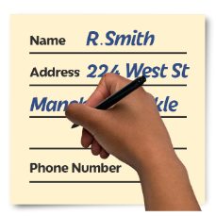

So that they can attend and vote on your behalf, you have to tell us their name and that you want them to be your Proxy.


If you change your mind and do come to the AGM after all, then your Proxy cannot vote for you and you can vote like everyone else.

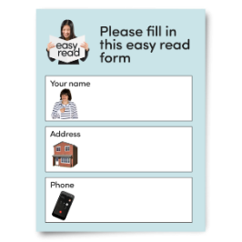
In case you are unable to come along on the day, it will really help us if you complete and send us a Proxy Form or fill it in online: https://www.xbyxbromley.org.uk/agm26.

In case you don’t know another X by X Member who is coming to the meeting, you can ask our Trustee, Kathryn Mitchell, to be your Proxy.

What we are asking you to do
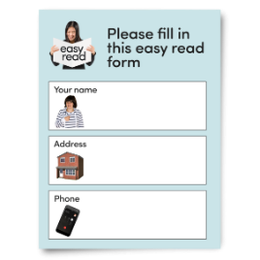

Please fill in our proxy form so that we have a backup in case you cannot come to our AGM.



We have an online form on our website: https://www.xbyxbromley.org.uk/agm26.




Or you can use the form enclosed and return to info@xbyxbromley.org.uk or send us a paper copy to Bromley Experts by Experience, Room 5, Anerley Town Hall and Business Centre, Anerley Road, Anerley, SE20 8BD.



We need the forms back before Monday 5th November.

You can still come along anyway, and we really hope you will!

Proxy Form (Easy Read):

Bromley Experts by Experience Annual General Meeting
Thursday 12th November 2026 2pm to 3.30pm



Your full name:



Your home address or email address:

By sending in this form, you agree that:

“If I cannot come to the AGM, I want Kathryn Mitchell to be my Proxy, unless I write the name of a different X by X Member who I want to be my Proxy in the space below.”

“Instead of Kathryn Mitchell, I want ………………………………… (name of X by X Member) to be my Proxy.”



Your signature:

(You only need to sign this if you cannot email the form to us and have to send a paper copy).



Any comments you want to make about voting?
You don’t have to write anything here, but you can if you want to tell us how you want your Proxy to vote (for example voting Yes to electing new Trustees).

Notes:


Unless you tell us how you want your Proxy to vote, the Proxy will vote how they think is best for X by X.


Remember, if you come to the AGM, you can vote for yourself, even if you have already sent us this Proxy Notice.

